**Devops Test cases Sample:  
  
Test case writing sample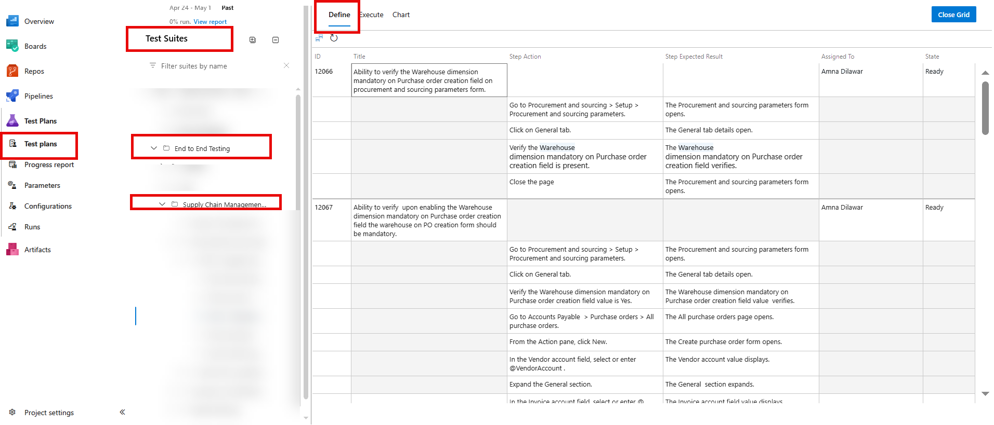 Bug Reporting Sample**